Hotel Booking Form
China’s nitrogen fertilizer market Forum 2004
Qingdao,Shandong,China 25– 26 April 2004
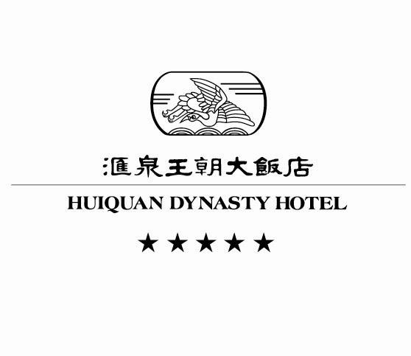
Add:9 Nanhai Road Qingdao, Shandong,China
Tel: 86-532-2999888
The Huiquan Dynasty Hotel is a 5-star hotel and managed by Hongkong Dynasty Group for 16 years. Warmly welcome every guest to attend the meeting in Qingdao Huiquan Dynasty Hotel .
*We kindly request you to fill out the from and send to us by Fax or E-mail before 16 April 2004.
Mr./ Ms. Mr./ Ms. Mr./ Ms.
Nationality: Company:
Tel: Fax: E-mail
Room Type: Sea-view Standard Room. □ RMB470/net
Dynasty Executive Room □ RMB610/net

April is the peak season in Qingdao, the Organizer has negotiated the best group rate for delegates in Huiquan Dynasty Hotel, a 5-star hotel managed by Hongkong Dynasty Group for 16 years. In order to enjoy the group rate, you should make reservations before 18 April 2004.
*All Room Rates are including 15% service charge and including Buffet breakfast.
Check-in Time: Check out time:
Arrival Detail:______________________No. of Rooms:_____________________
Special requests:
Payment: □ Cash □Card □VISA □JCB
Contact personnel: Christine Tai
TEL: 86-532-2999971 FAX:86-532-2896204
E-mail:christinetai@126.com
For secretariat use only
Date:
Reg. NO:

